COMPUTER SOCIETY OF INDIA STUDENT CHAPTER (CSI)

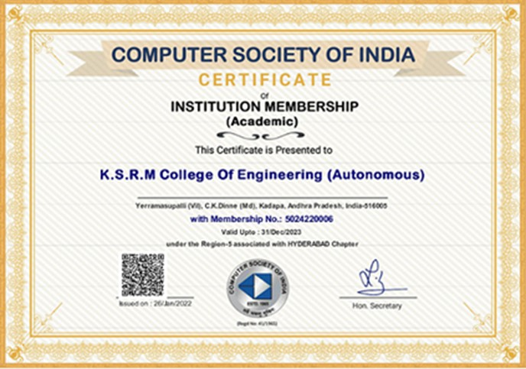

CSI MEMBERSHIP CERTIFICATE

S. No | Academic Year | Event Name/ Date | No. of Participants | POs
1 | 2023-24 | HACK CHALLENGE(12-09-23) | 45 | PO3
2 | 2023-24 | GUST LECTURE ON ENTREPRENEURSHIP(28-08-23) | 86 | PO4
3 | 2022-23 | BYTEMASTER(19-06-2023) | 21 | PO1
4 | 2022-23 | PY QUIZ  (20.08.2022) | 46 | PO1
5 | 2022-23 | Advanced Python programming workshop  (15.05.23 to 17.05.2023) | 49 | PO1
6 | 2022-23 | Awareness on CSI  (17-11-2022) | 230 | PO1
7 | 2022-23 | OUT Reach Program on Digitalization(15-11-2022) | 21 | PO6
8 | 2022-23 | CRYPT YOUR MIND  (14-10-2022) | 12 | PO1
9 | 2022-23 | SELECT *FROM SQL  (18-09-22) | 41 | PO1
10 | 2022-23 | ODE TO CODE  (13-09-22 TO 14-09-22) | 37 | PO1
11 | 2022-23 | GUST LECTURE ON ENTREPRENEURSHIP (20-08-2022) | 47 | PO4
12 | 2022-23 | Reasoning Test  (14-07-22) | 38 | PO1
13 | 2021-22 | Aptitude Test  (30-06-22) | 48 | PO1
14 | 2021-22 | Project/App Expo 2K22  (03-06-22) | 61 | PO9
15 | 2021-22 | Workshop on Career Development  (25-05-22 to27-07-22) | 24 | PO1
16 | 2021-22 | BFS-Technical symposium  (18-05-22) | 77 | PO1
17 | 2021-22 | CODIGO  (28-03-22) | 24 | PO1

